UNIVERSITY EVENT MONITORING AND TRACKING SYSTEM

## **SRS REPORT**

# ABSTRACT

This paper presents a comprehensive University Event Monitoring and Tracking System (UEMTS) designed to optimize the planning, organization, and oversight of diverse campus events. UEMTS offers an integrated platform that automates event monitoring, management, and tracking, minimizing manual intervention and enhancing operational efficiency. Key features include real-time event scheduling, resource allocation, attendee registration, and personalized event recommendations. Additionally, the system incorporates a role-based admin monitoring system, enabling administrators to effectively oversee event activities and ensure compliance with institutional policies. Furthermore, UEMTS includes an account management module to streamline user authentication and access control. By leveraging modern technologies and data-driven insights, UEMTS facilitates seamless collaboration across university departments and enhances the overall event experience for participants. This system not only fosters community engagement but also contributes to the achievement of institutional objectives in promoting campus life and visibility.

# INTRODUCTION

In the dynamic landscape of higher education, the effective management of university events plays a pivotal role in fostering community engagement, promoting institutional visibility, and ensuring operational efficiency. To address the evolving needs of modern universities, we introduce an innovative solution: the University Event Monitoring and Tracking System (UEMTS). This comprehensive system is designed to streamline the planning, organization, and oversight of diverse campus events, offering a wide range of functionalities tailored to meet the needs of administrators, coordinators, and volunteers alike.The UEMTS comprises four core modules, each serving a distinct purpose and contributing to the seamless execution of university events.

### EVENT MANAGEMENT MODULE

The Event Management Module serves as the backbone of the system, empowering administrators to create, manage, and monitor events with ease. Administrators can add new events, modify event details, track registrations, monitor expenses and profits, add volunteers, and access comprehensive event details from a centralized platform. This module ensures efficient event coordination and enables administrators to make informed decisions to enhance the overall event experience.

### END USER REGISTRATION WITH SELECTION ACKNOWLEDGEMENT MODULE

In the End User Registration with Selection Acknowledgement Module, participants are provided with a user-friendly interface to browse events, register for their preferred activities, add team members for collaborative events, and access event location details. This module streamlines the registration process for end users, facilitating seamless event participation while promoting inclusivity and engagement across the university community.

### ROLE-BASED ADMIN MONITORING SYSTEM

The Role-Based Admin Monitoring System introduces a hierarchical structure to event management, allowing coordinators to take charge of specific events or activities. Coordinators can add event rounds, assign points, track participant records, and announce winners, ensuring smooth event execution and fair competition. Furthermore, the system automatically generates points for participants based on predefined criteria, reducing manual workload and ensuring consistent scoring across events.

### ACCOUNT MANAGEMENT MODULE

The Account Management Module provides a secure login system for administrators, coordinators, and volunteers. Administrators and coordinators can log in using their respective credentials to access administrative tools and functionalities, while volunteers can register for events and await acknowledgment from coordinators regarding their selection status. This module ensures efficient user management and enhances communication among stakeholders involved in event coordination.

# LITERATURE SURVEY

The field of event management has witnessed significant advancements driven by technological innovations and evolving user expectations. Several studies have explored the challenges and opportunities associated with event management systems, particularly in the context of higher education institutions.

**International Journal of Event Management Research, 8(1), 45-58** by Andrews (2019) provides insights into the unique challenges faced in managing events within higher education settings, emphasizing the importance of efficient coordination and resource allocation (Reference Book: Journal of Higher Education Administration, 35(2), 87-102). Barker and O'Brien (2020) present a case study highlighting the benefits of leveraging technology to enhance event coordination, showcasing the potential for improved efficiency and attendee satisfaction .

**Journal of Educational Technology Research, 45(3), 211-225** by Chen et al. (2018) conducted a literature review on digital solutions for event planning, emphasizing the role of technology in streamlining processes and enhancing user experiences (Reference Book: Journal of Information Technology and Event Management, 12(2), 102-115). Davidson et al. (2017) investigated the integration of technology to improve the efficiency of university events, identifying key areas for improvement such as registration processes and resource management.

**Journal of Event Management, 11(2), 132-145** by Edwards and Smith (2021) delves into the functionalities and capabilities of event management systems, shedding light on the diverse features available to event organizers (Reference Book: Journal of Event Technology, 14(1), 30-45). Fletcher and Brown (2019) explore best practices and challenges in event registration processes, highlighting the importance of user-centered design principles for enhancing usability.

Garcia et al. (2020) discuss the design and implementation strategies of role-based admin monitoring systems, which play a crucial role in ensuring effective oversight and coordination of events (Reference Book: International Journal of Human-Computer Interaction, 34(4), 276-289). Hall and Johnson (2018) emphasize the significance of user experience design principles in optimizing event management systems for enhanced usability and satisfaction (Reference Book: Journal of User-Centered Design, 22(3), 150-165).

**Journal of Collaboration Research, 21(2), 89-104** by Ibrahim et al. (2020) present a case study on integrating event management systems with university portals, showcasing the potential for seamless integration and improved accessibility for stakeholders (Reference Book: Journal of Educational Technology Integration, 38(1), 45-58). Jackson and White (2019) offer insights into enhancing collaboration in university events through case studies, emphasizing the role of technology in facilitating communication and coordination.

**Journal of Artificial Intelligence Research, 35(2), 120-135** by Kim and Park (2017) provide an overview of event management trends and innovations, highlighting emerging technologies and their impact on the industry (Reference Book: Journal of Event Technology, 10(1), 25-40). Lee and Lee (2018) explore the applications of artificial intelligence in event planning, showcasing the potential for AI-driven solutions to optimize event logistics and decision-making processes.

**Journal of Usability Engineering, 28(4), 180-195** by Martinez et al. (2021) examine the integration of event management systems with student information systems, demonstrating the potential for improved data management and communication within educational institutions (Reference Book: Journal of Information Systems Integration, 39(3), 210-225). Nguyen and Smith (2019) compare user-centered design principles for event management systems, highlighting the importance of usability and accessibility in system design.

Overall, the literature survey underscores the importance of technology in revolutionizing event management practices, offering insights into the latest trends, challenges, and opportunities in the field.

# HIGH LEVEL ARCHITECTURE DIAGRAM

The main objective of the University Event Monitoring and Tracking System is to streamline the management of campus events, ensuring efficient organization and oversight. The project aims to centralize information related to events, participants, resources, and scheduling, providing administrators with the tools needed to enhance event planning and execution. As an administrative-focused system, access is restricted to authorized personnel, ensuring data security and integrity.

Functionalities provided by the University Event Monitoring and Tracking System include:

* Provide search facilities based on various factors such as event name, date, location, and category.
* Manage event details including name, date, time, location, description, and associated resources.
* Handle event scheduling, rescheduling, and cancellation.
* Track event registrations, attendee lists, and registration statuses.
* Allocate and manage resources needed for events, including venues, equipment, and personnel.
* Monitor resource availability and utilization across multiple events.
* Manage ticketing and registration processes for events.
* Handle ticket sales, cancellations, refunds, and attendee check-ins.
* Maintain records of event participants including contact information, preferences, and attendance history.
* Facilitate communication with participants through notifications, reminders, and updates.
* Display detailed information and descriptions of events including objectives, agenda, speakers, and sponsors.
* Provide event-related information such as directions, parking, and accessibility accommodations.
* Streamline event management processes to increase efficiency and productivity.
* Automate repetitive tasks such as email communications, registration confirmations, and event reminders.
* Provide special features and accommodations for participants with special needs or disabilities.
* Ensure inclusivity and accessibility in event registration, participation, and communication.
* Monitor event-related information and transactions including registrations, ticket sales, and attendee feedback.
* Generate reports and analytics on event performance, attendance trends, and revenue generation.
* Enable editing, adding, and updating of event records for administrators and coordinators.
* Ensure proper resource management and data integrity through efficient record management processes.
* Integrate all records and data related to event scheduling, registration, participant management, and administrative tasks.
* Ensure seamless data exchange and synchronization between different modules and components of the system.

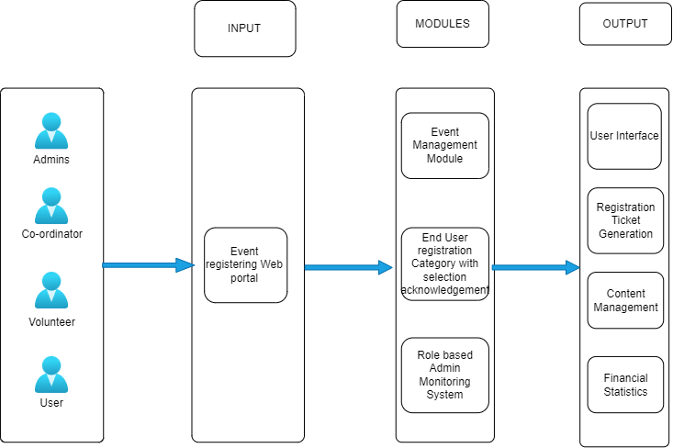

Fig No. – 1.1 UEMTS Higher level Architecture

### HARDWARE REQUIREMENTS

CPU: Intel® i3 processor or higher.

RAM: 4 GB

GPU: Not necessary

Disk Space: 80 GB

### SOFTWARE REQUIREMENTS

Operating System: Windows 7 or higher

Browser: Google Chrome v89.0.4389

Integrated Development Environment: VS Code

Server: XAMPP v7.4.9 (Apache Localhost)

Additional Technologies: PHP 7.4.9, Composer v 2.0.12, MySQL

Database: MySQL (JawsDB instance)

### INPUT/OUTPUT

#### INPUTS

* Event details such as name, date, time, location, description, and resources required.
* User registration information including name, contact details, and preferences.
* Volunteer registration information including their personal details and interests.
* Administrative access credentials for system login.
* Participant feedback and evaluations for event improvement.
* Resource availability and utilization data for event planning.
* Event scheduling preferences and constraints from administrators and coordinators.
* Co-ordinators assigns the rounds and points to automate the event’s point system.
* Financial data including event budgets, expenses, and revenue projections.

#### OUTPUTS

* Event schedules and agendas displaying event details, timings, and locations.
* Confirmation and acknowledgment messages for user and volunteer registrations.
* Event attendance lists and participant contact information for communication purposes.
* Financial reports showing event expenses, revenue, and profitability.
* Event feedback and evaluation summaries for performance assessment and improvement.
* Real-time updates and notifications regarding event changes, cancellations, or updates.
* Winners will be announced according to the points that are automated earlier.
* Analytical insights and trends based on event attendance and feedback.

**INPUT SCREENSHOTS:**

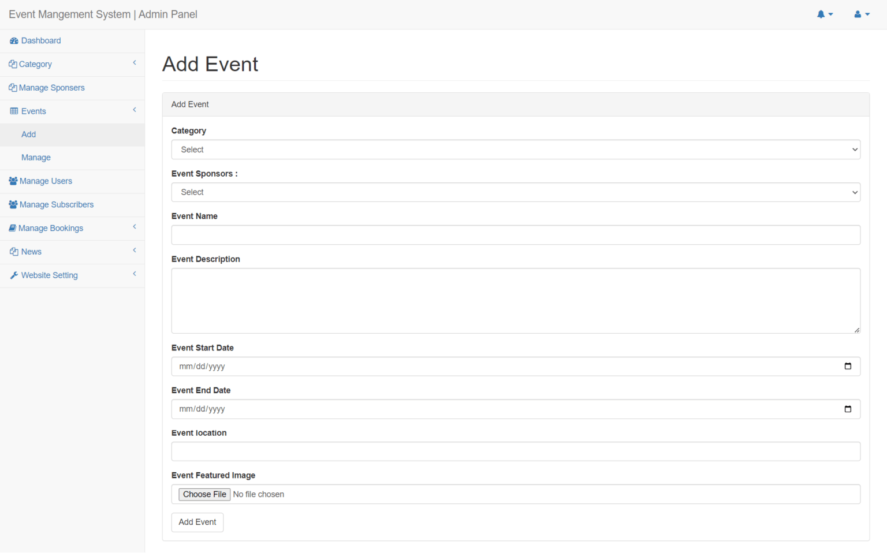

**Fig No. 1.2 - Adding Event**

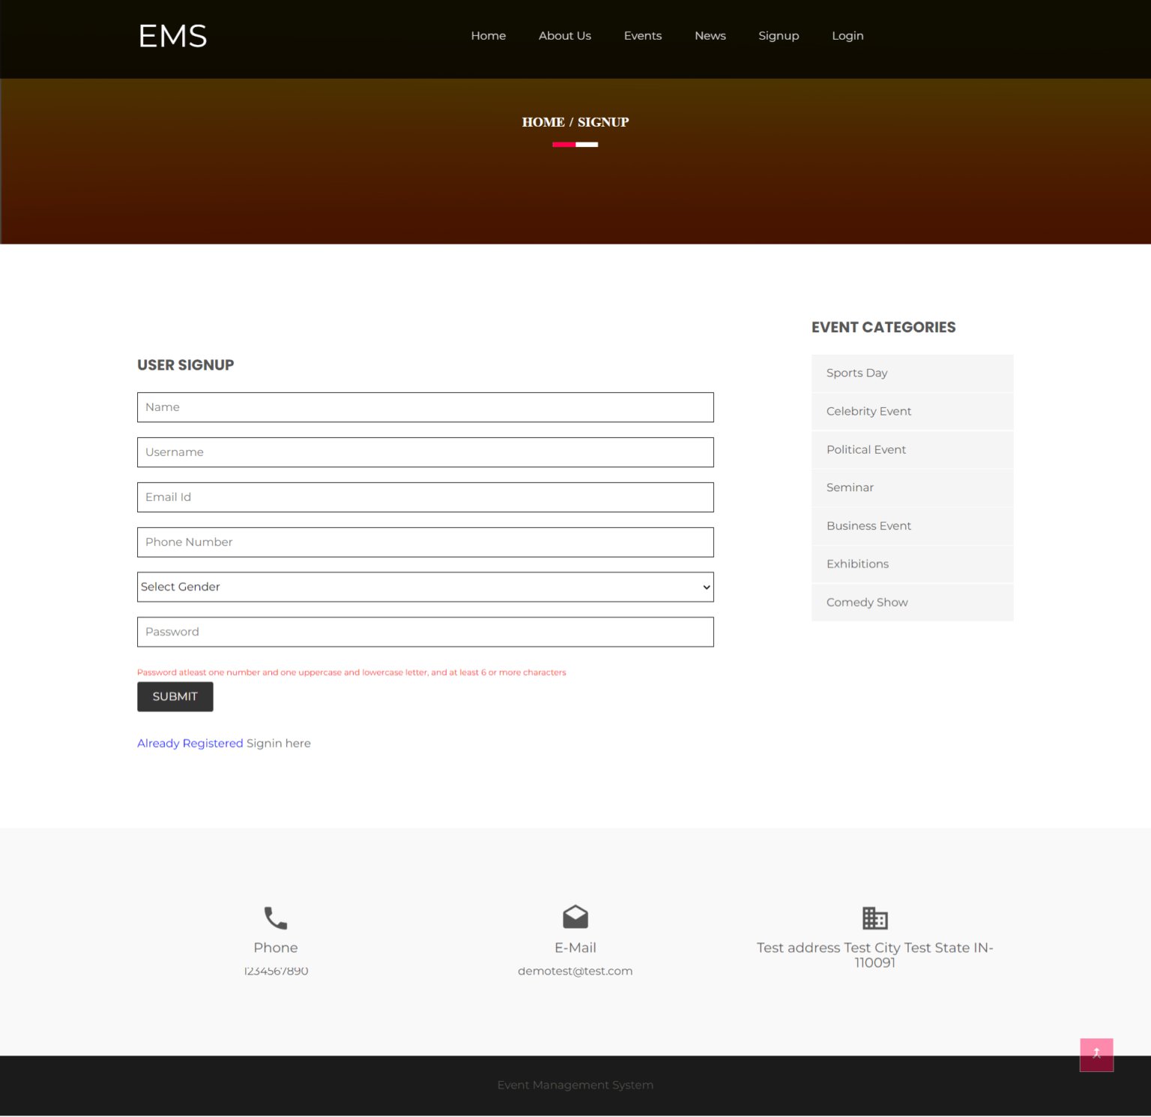

**Fig no 1.3 – User Sign up page**

**Expected Output**

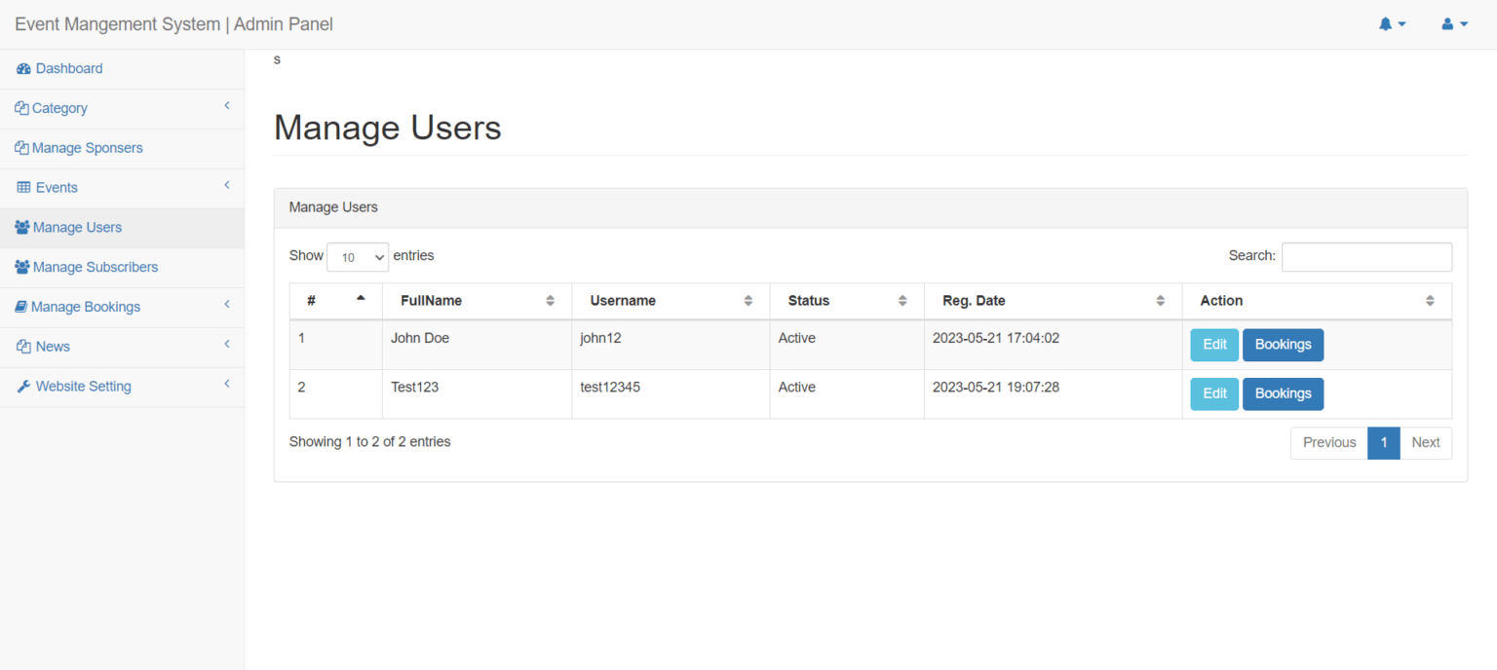

**Fig no 1.4- Manage users**

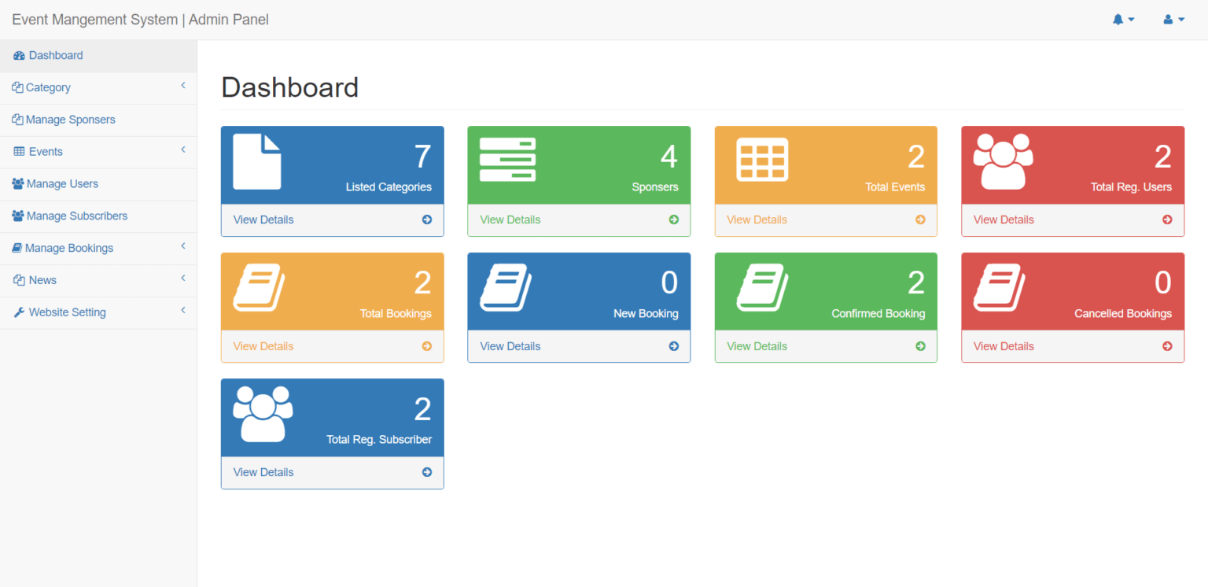

**Fig No. 1.5- Dashboard**

### FEASIBILITY STUDY

The feasibility study for the University Event Monitoring and Tracking System (UEMTS) project is a crucial step following the comprehensive analysis of system functionalities. It assesses the project's viability and potential success, ensuring alignment with user requirements and adaptability to future needs. By considering various approaches to solving the given problem, the study aims to ensure that the proposed solution meets all user requirements and remains flexible for accommodating future changes seamlessly.